|  |  |  |  |  |  |
| --- | --- | --- | --- | --- | --- |
|  | *Function*[5](https://decentrale.regelgeving.overheid.nl/cvdr/xhtmloutput/Historie/Rotterdam/486392/486392_1.html#noot_id1-3-2-4-91-1-7-1-2-1-2) | *Note* | *Number of car parking spaces per 100 m2 GFA unless otherwise specified (see comments)* | | |
|  |  |  | *Zone A Metropolitan area* | *Zone B City districts* | *Zone C.*  *Other* |
| **To work** | Office |  | 0.76 | 1.00 | 1.20 |
|  | Multi-tenant building / Atelier |  | 0.72 | 0.80 | 0.80 |
|  | Labor-intensive / visitor-intensive company (industry, laboratory workshop, etc.) |  | 0.67 | 1.20 | 2.00 |
|  | Labor-extensive / visitor-extensive company (warehouse, storage, transport company, etc.) | shed for storage | 0.19 | 0.30 | 0.60 |
| **Shop** | Commercial services and offices with counter function |  | 1.20 | 2.00 | 2.50 |
|  | Retail including thrift store and pharmacy | I guess this is general shops/general retail | 0.38 | 2.50 | 2.50 |
|  | Supermarket |  | 0.38 | 2.50 | 2.80 |
|  | Basket supermarket | Maximum size 500m2 GFA | 0.0 | 0.0 | 0.0 |
|  | Large-scale retail |  | n / a | 4.50 | 5.50 |
|  | DIY store, garden center, thrift store |  | n / a | 2.20 | 2.20 |
|  | Showroom, furniture store |  | 0.26 | 0.60 | 0.60 |
| **Sports and recreation** | Gym, indoor sports hall (incl. Squash, tennis) |  | 0.08 | 1.70 | 2.00 |
|  | Outdoor sports field (incl. Tennis court) | Standard basis:  ha. net terrain | 0.65 | 13.00 | 13.00 |
|  | Dance studio, gym |  | 0.10 | 2.00 | 3.00 |
|  | Marina | Standard basis: berth | 0.05 | 0.50 | 0.50 |
| **Culture** | Museum |  | 0.02 | 0.40 | 0.70 |
|  | Library |  | 0.01 | 0.50 | 0.90 |
|  | Cinema, theater, theater | Standard basis: per seat | 0.01 | 0.10 | 0.20 |
|  | Social cultural center, neighborhood building |  | 010 | 0.90 | 1.00 |
|  | Religion building | Standard basis: per visitor's place | 0.01 | 0.10 | 0.15 |
| **catering industry** | Cafeteria / snack bar (catering I) |  | 0.40 | 4.00 | 6.00 |
|  | Disco / party room (catering II) |  | 0.70 | 7.00 | 10.00 |
|  | Café / bar (catering III) |  | 0.40 | 4.00 | 6.00 |
|  | Restaurant (catering IV) |  | 1.60 | 8.00 | 12.00 |
|  | Hotel 1, 2, 3 stars (catering V) | Per 10 rooms, (excluding conference and meeting facilities) | 1.60 | 2.40 | 4.10 |
|  | Hotel 4, 5 stars (catering V) | Per 10 rooms, (excluding conference and meeting facilities) | 4.70 | 6.90 | 9.10 |
| **Education** | Crèche, playgroup, nursery |  | 0.80 | 0.90 | 1.00 |
|  | Primary education | Standard basis:  classroom 30 students (excl. Kiss & Ride strip) | 0.40 | 0.45 | 0.50 |
|  | Preparatory daytime education  (VMBO, HAVO, VWO) | Standard basis: classroom 30 pupils | 0.40 | 0.45 | 0.50 |
|  | Vocational education and WO/universities | Standard basis: classroom 30 pupils | 0.50 | 2.00 | 3.00 |
| **Care** | Hospital | Standard basis:  per bed | 1.10 | 1.30 | 1.50 |
|  | Nursing home, convalescence home, hospice | Standard basis:  per housing unit | 0.40 | 0.45 | 0.50 |
|  | 1 e  -line healthcare  (general practitioner, dentist, therapist) | Standard basis:  per treatment room | 0.53 | 1.70 | 2.00 | |

*Table 4.2: Standards table for car non-residential functions*

Based on Articles 6.4 and 6.5 (see Section 2.2), it may be decided to apply a lower parking standard of 0.6 car parking spaces per home for care homes and social housing below the liberalization limit.

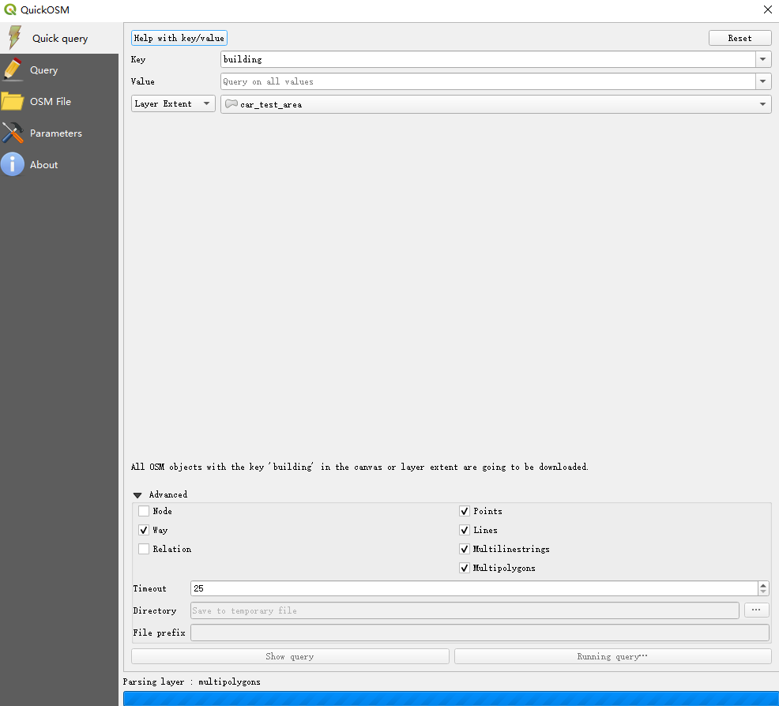

* *

*Proximity to public transport* *stations:*  If a development is realized in the vicinity of the public transport stations listed in the table below, the car parking requirement will be reduced in accordance with this (table 2.3). The area division used (zones A, B and C) is regulated in chapter 3 of these policy rules.

|  |  |  |  |
| --- | --- | --- | --- |
| *Public transport stop* | *Development as the crow flies - public transport stop entrance* | | |
|  | *0 - 400 meters* | *400 - 800 meters* | *800 - 1200 meters* |
| Rotterdam Central | -50% | -40% | -30% |
| Beurs, Blaak and Schiedam Center | -40% | -30% | -20% |
| Other train stations | -30% | -20% | -10% |
| Other RSR / metro stations within zones A and B | -30% | -20% | -10% |
| Other tram stops within zone A | -30% | -20% | -10% |
| RSR / metro stations zone C (except Hoek van Holland and Nesselande) | -20% | -10% | -5% |
| Other tram stops in zone B | -20% | -10% | -5% |
| RSR / metro stations in Hoek van Holland and Nesselande | -10% | -5% | 0 |
| Other tram stops in zone C. | -10% | -5% | 0 |
| Alexander | 0 | 0 | 0 |

*Table 2.3: Exemption from parking requirement for proximity to public transport*

* Only train/tram/metro stops involved

0 means no discount on the requirements (we don’t need to do any operation on it)

* *

*Proximity to public transport stations:*  If a development is realized in the vicinity of the public transport stations listed in the table below, the car parking requirement will be reduced in accordance with this (table 2.3). The area division used (zones A, B and C) is regulated in chapter 3 of these policy rules.

|  |  |  |  |
| --- | --- | --- | --- |
| *Public transport stop* | *Discount factor* | | |
|  | *0 - 400 meters* | *400 - 800 meters* | *800 - 1200 meters* |
| Rotterdam Central | 0.5 | 0.6 | 0.7 |
| Beurs, Blaak and Schiedam Center | 0.6 | 0.7 | 0.8 |
| Other train stations | 0.7 | 0.8 | 0.9 |
| Other RSR / metro stations within zones A and B | 0.7 | 0.8 | 0.9 |
| Other tram stops within zone A | 0.7 | 0.8 | 0.9 |
| RSR / metro stations zone C (except Hoek van Holland and Nesselande) | 0.8 | 0.9 | 0.95 |
| Other tram stops in zone B | 0.8 | 0.9 | 0.95 |
| RSR / metro stations in Hoek van Holland and Nesselande | 0.9 | 0.95 | 1 |
| Other tram stops in zone C. | 0.9 | 0.95 | 1 |
| Alexander | 1 | 1 | 1 |

*Table 2.3: Exemption from parking requirement for proximity to public transport*

* Only train/tram/metro stops involved

0 means no discount on the requirements (we don’t need to do any operation on it)

Discount factor table

For each place only select one point to do buffer (there are many points close to each other in one station)

Therefore, only use one point to represent each station

* *

*Proximity to public transport* *stations:*  If a development is realized in the vicinity of the public transport stations listed in the table below, the car parking requirement will be reduced in accordance with this (table 2.3). The area division used (zones A, B and C) is regulated in chapter 3 of these policy rules.

|  |  |  |  |
| --- | --- | --- | --- |
| *Public transport stop* | *Development as the crow flies - public transport stop entrance* | | |
|  | *0 - 400 meters* | *400 - 800 meters* | *800 - 1200 meters* |
| Rotterdam Central | -50% | -40% | -30% |
| Beurs, Blaak and Schiedam Center | -40% | -30% | -20% |
| Other train stations | -30% | -20% | -10% |
| RSR / metro stations zone C (except Hoek van Holland and Nesselande) | -20% | -10% | -5% |
|  |  |  |  |
| RSR / metro stations in Hoek van Holland and Nesselande | -10% | -5% | 0 |

*Table 2.3: Exemption from parking requirement for proximity to public transport*

* Only train/tram/metro stops involved

|  |  |  |  |  |  |
| --- | --- | --- | --- | --- | --- |
| Simplify version | *Function*[5](https://decentrale.regelgeving.overheid.nl/cvdr/xhtmloutput/Historie/Rotterdam/486392/486392_1.html#noot_id1-3-2-4-91-1-7-1-2-1-2) | *Note* | *Number of car parking spaces per 100 m2 GFA unless otherwise specified (see comments)* | | |
|  |  |  | *Zone A Metropolitan area* | *Zone B City districts* | *Zone C.*  *Other* |
| **To work** | Office |  | 0.76 | 1.00 | 1.20 |
|  | Atelier |  | 0.72 | 0.80 | 0.80 |
|  | Industry |  | 0.67 | 1.20 | 2.00 |
|  | Warehouse | shed for storage | 0.19 | 0.30 | 0.60 |
| **Shop** | Commercial services |  | 1.20 | 2.00 | 2.50 |
|  | Retail | I guess this is general shops/general retail | 0.38 | 2.50 | 2.50 |
|  | Supermarket |  | 0.38 | 2.50 | 2.80 |
|  | Basket supermarket | Maximum size 500m2 GFA | 0.0 | 0.0 | 0.0 |
|  | Large-scale retail |  | n / a | 4.50 | 5.50 |
|  | DIY store |  | n / a | 2.20 | 2.20 |
|  | Showroom |  | 0.26 | 0.60 | 0.60 |
| **Sports and recreation** | Gym |  | 0.08 | 1.70 | 2.00 |
| None | Outdoor sports field (incl. Tennis court) | Standard basis:  ha. net terrain | 0.65 | 13.00 | 13.00 |
|  | gym |  | 0.10 | 2.00 | 3.00 |
| None | Marina | Standard basis: berth | 0.05 | 0.50 | 0.50 |
| **Culture** | Museum |  | 0.02 | 0.40 | 0.70 |
|  | Library |  | 0.01 | 0.50 | 0.90 |
|  | Cinema | Standard basis: per seat | 0.01 | 0.10 | 0.20 |
|  | Social cultural center |  | 010 | 0.90 | 1.00 |
|  | Religion | Standard basis: per visitor's place | 0.01 | 0.10 | 0.15 |
| **catering industry** | catering I | Cafeteria / snack bar | 0.40 | 4.00 | 6.00 |
|  | catering II | Disco / party room | 0.70 | 7.00 | 10.00 |
|  | catering III | Café / bar | 0.40 | 4.00 | 6.00 |
|  | catering IV | Restaurant | 1.60 | 8.00 | 12.00 |
|  | Hotel 1, 2, 3 stars (catering V) | Per 10 rooms, (excluding conference and meeting facilities) | 1.60 | 2.40 | 4.10 |
|  | Hotel 4, 5 stars (catering VI) | Per 10 rooms, (excluding conference and meeting facilities) | 4.70 | 6.90 | 9.10 |
| **Education** | nursery |  | 0.80 | 0.90 | 1.00 |
|  | Primary education | Standard basis:  classroom 30 students (excl. Kiss & Ride strip) | 0.40 | 0.45 | 0.50 |
|  | Preparatory daytime education  (VMBO, HAVO, VWO) | Standard basis: classroom 30 pupils | 0.40 | 0.45 | 0.50 |
|  | Vocational education and WO/universities | Standard basis: classroom 30 pupils | 0.50 | 2.00 | 3.00 |
| **Care** | Hospital | Standard basis:  per bed | 1.10 | 1.30 | 1.50 |
|  | Nursing home | Standard basis:  per housing unit | 0.40 | 0.45 | 0.50 |
|  | healthcare | Standard basis:  per treatment room  (general practitioner, dentist, therapist) | 0.53 | 1.70 | 2.00 | |